**Sum-of-subsets, Hamiltonian cycles**

# Subset-Sum Problem

The Subset-Sum Problem is to find a subset's' of the given set S = (S1 S2 S3...Sn) where the elements of the set S are n positive integers in such a manner that s'∈S and sum of the elements of subset's' is equal to some positive integer 'X.'

The Subset-Sum Problem can be solved by using the backtracking approach. In this implicit tree is a binary tree. The root of the tree is selected in such a way that represents that no decision is yet taken on any input. We assume that the elements of the given set are arranged in increasing order:

S1 ≤ S2 ≤ S3... ≤ Sn

The left child of the root node indicated that we have to include 'S1' from the set 'S' and the right child of the root indicates that we have to execute 'S1'. Each node stores the total of the partial solution elements. If at any stage the sum equals to 'X' then the search is successful and terminates.

The dead end in the tree appears only when either of the two inequalities exists:

* The sum of s' is too large i.e.

s'+ Si + 1 > X

* The sum of s' is too small i.e.

Subset-Sum Problem

**Example:** Given a set S = (3, 4, 5, 6) and X =9. Obtain the subset sum using Backtracking approach.

**Solution:**

1. Initially S = (3, 4, 5, 6) and X =9.
2. S'= (∅)

The implicit binary tree for the subset sum problem is shown as fig:

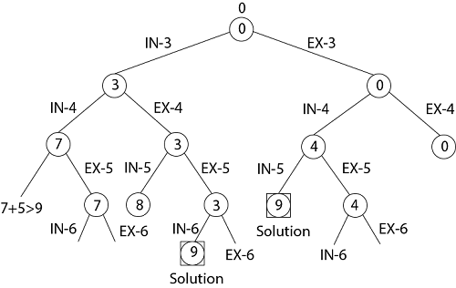

The number inside a node is the sum of the partial solution elements at a particular level.

Thus, if our partial solution elements sum is equal to the positive integer 'X' then at that time search will terminate, or it continues if all the possible solution needs to be obtained.

**Hamiltonian Circuit Problems**

Given a graph G = (V, E) we have to find the Hamiltonian Circuit using Backtracking approach. We start our search from any arbitrary vertex say 'a.' This vertex 'a' becomes the root of our implicit tree. The first element of our partial solution is the first intermediate vertex of the Hamiltonian Cycle that is to be constructed. The next adjacent vertex is selected by alphabetical order. If at any stage any arbitrary vertex makes a cycle with any vertex other than vertex 'a' then we say that **dead end** is reached. In this case, we backtrack one step, and again the search begins by selecting another vertex and backtrack the element from the partial; solution must be removed. The search using backtracking is successful if a Hamiltonian Cycle is obtained.

**Example:** Consider a graph G = (V, E) shown in fig. we have to find a Hamiltonian circuit using Backtracking method.

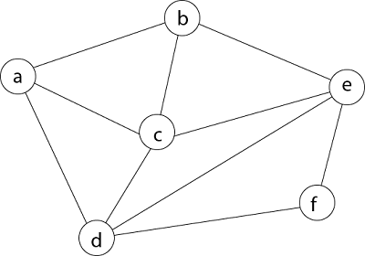

**Solution:** Firstly, we start our search with vertex 'a.' this vertex 'a' becomes the root of our implicit tree.

Hamiltonian Circuit Problems

Next, we choose vertex 'b' adjacent to 'a' as it comes first in lexicographical order (b, c, d).

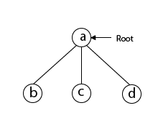

Next, we select 'c' adjacent to 'b.'

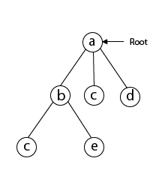

Next, we select 'd' adjacent to 'c.'

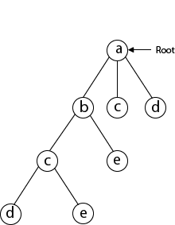

Next, we select 'e' adjacent to 'd.'

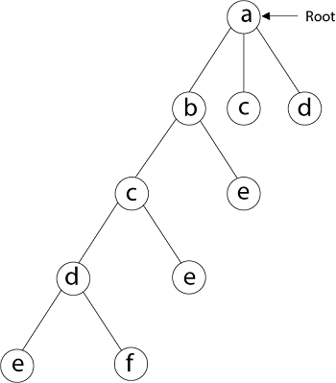

Next, we select vertex 'f' adjacent to 'e.' The vertex adjacent to 'f' is d and e, but they have already visited. Thus, we get the dead end, and we backtrack one step and remove the vertex 'f' from partial solution.

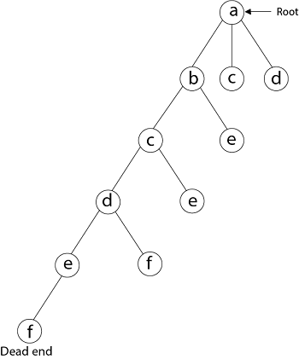

From backtracking, the vertex adjacent to 'e' is b, c, d, and f from which vertex 'f' has already been checked, and b, c, d have already visited. So, again we backtrack one step. Now, the vertex adjacent to d are e, f from which e has already been checked, and adjacent of 'f' are d and e. If 'e' vertex, revisited them we get a dead state. So again we backtrack one step.

Now, adjacent to c is 'e' and adjacent to 'e' is 'f' and adjacent to 'f' is 'd' and adjacent to 'd' is 'a.' Here, we get the Hamiltonian Cycle as all the vertex other than the start vertex 'a' is visited only once. (a - b - c - e - f -d - a).

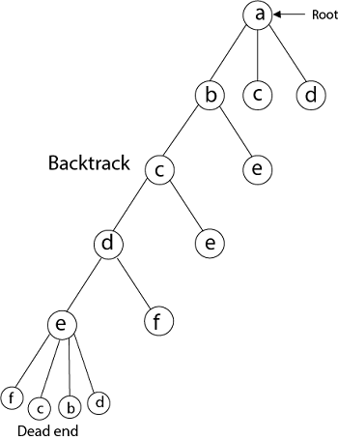

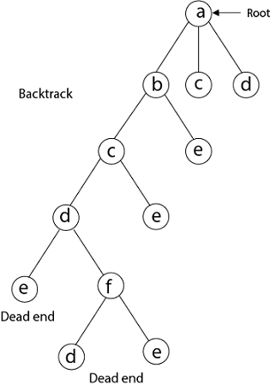

**Again Backtrack**

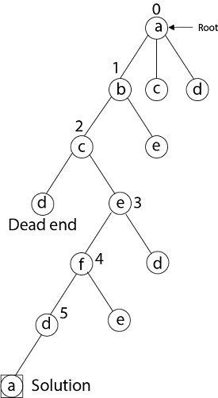  
Here we have generated one Hamiltonian circuit, but another Hamiltonian circuit can also be obtained by considering another vertex.

**RELEVANT READING MATERIAL AND REFERENCES:**

**Source Notes:**

* 1. <https://www.javatpoint.com/subset-sum-problems>
  2. <https://www.javatpoint.com/hamiltonian-circuit-problems>

**Lecture Video:**

1. <https://youtu.be/kyLxTdsT8ws>

**Online Notes:**

1. <http://vssut.ac.in/lecture_notes/lecture1428551222.pdf>

**Text Book Reading:**

1. Cormen, Leiserson, Rivest, Stein, “*Introduction to Algorithms*”, Prentice Hall of India, 3rd edition 2012. problem, Graph coloring.

**In addition: PPT can be also be given.**